Square root using newton's method (java) Project pictures

Total images: 04

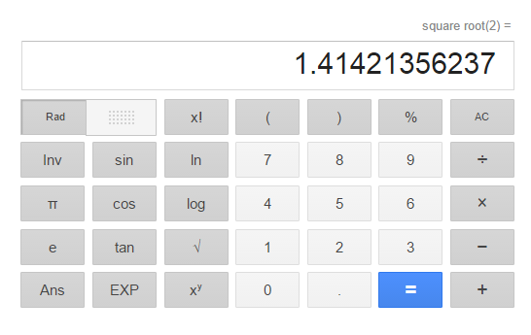

Fig 1: Square root of 2 on google

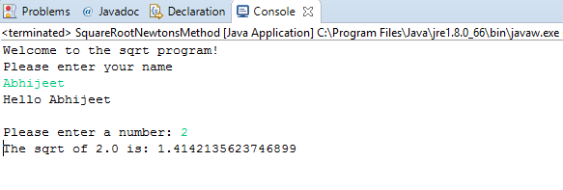

Fig 2: Our program, Square root of 2

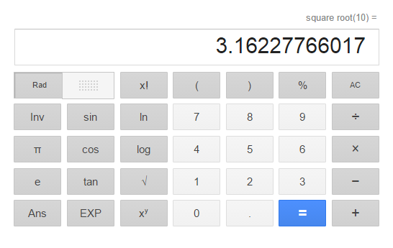

Fig 3: Square root of 10 on google

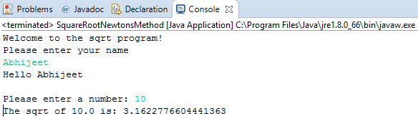

Fig 4: Our program, Square root of 10